1. Congratulations! If you have completed these steps, you should able to log in.

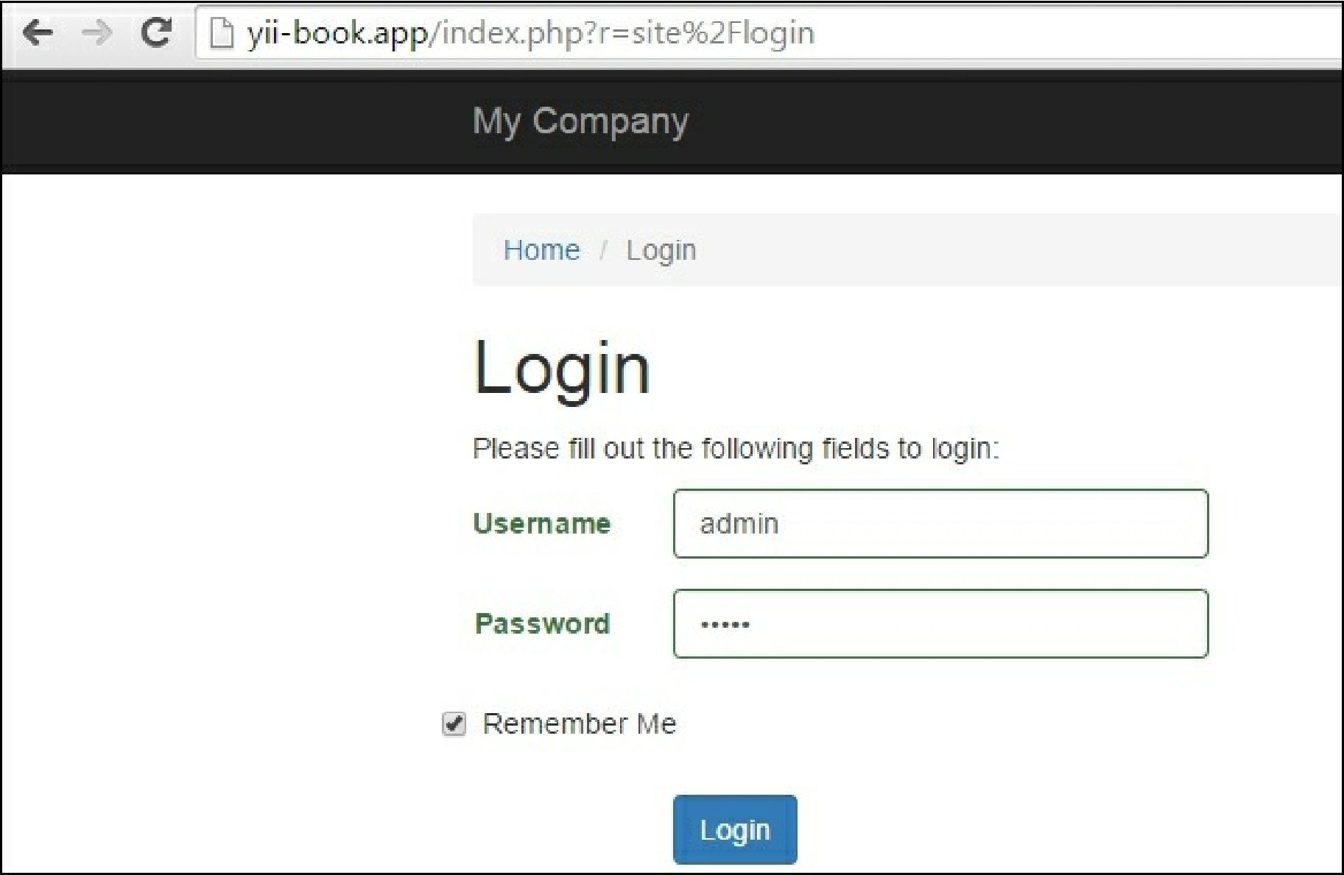

How it works...

1. First, we created a migration for the user table. Apart from our ID and username, our table contains special fields such as auth_key (the main use of this is to authenticate the user by cookie), password_hash (for security reasons we won’t store the password as it is and will store only the password hash), and password_reset_token (used when we need to reset the user’s password).
2. The result after installation and create_test_user migration should look like the following screenshot:

We’ve also added special methods to the User model and changed the inheritance to class User extends ActiveRecord implements Identityinterface because we need to be able to find users in the

id username authkey password_hash password_reset_token

1 admin ninGOh3j0C5zIMxAk92CpYZJ 1 cMSGMM J2yS13SKJ8RjbY3DCgdFxQOvW82N m2Zrti6F6pPjde2Fblg3gH8 HULL